**SQL Assignment: All concepts I**

**Download the following database file from the link:**

**AirlineDB**: https://drive.google.com/file/d/15ehp3FtyuYqExne3FaFcWHB4TFI_vtSR/view?usp=sharing

**Table structure**

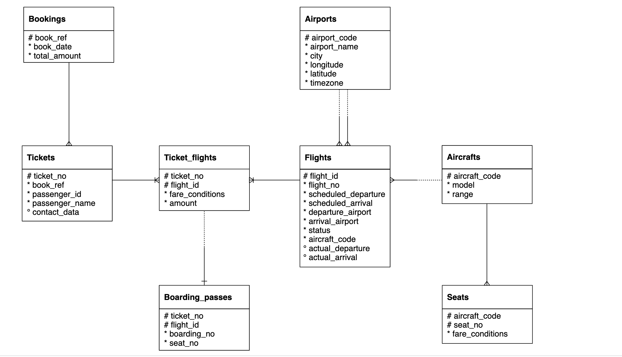

Important Instructions:

* Download the database link and restore in postgres. For restoration, you can refer to the instructions in the first chapter of SQL
* The AirlineDB is quite big in size, hence restoration might take time. Once the restoration starts, wait for 15 to 20 mins and don’t shut down the computer
* Table names in database has “**booking.”** as prefix. For example, bookings.tickets, bookings.boarding_passes. Hence use the prefix in the query as well
  + Correct way of accessing tables: SELECT * FROM **bookings.tickets**
  + Wrong way of accessing tables: SELECT * FROM tickets
* Queries need to be submitted in a **word/text file**. CSV output of the queries will **NOT** be accepted
* Expected output written is written in some of the following question to make sure that you are getting the columns in the same sequence. It doesn’t mean that you will get same values in the output. The exact values in your queries might be different depending on the values sorted in your copy of database.

1. Represent the “book_date” column in “yyyy-mmm-dd”. User Bookings table

*Expected output*

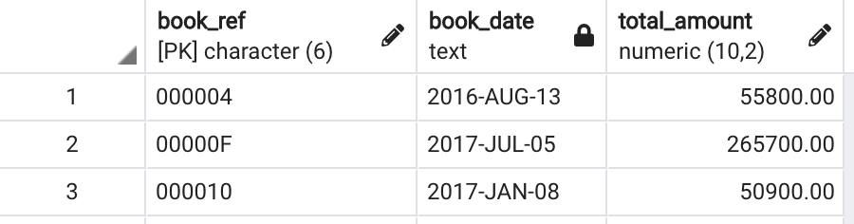

ANS: SELECT book_ref, to_char(book_date, 'yyyy-MON-dd') as book_date, total_amount

from bookings.bookings;

1. Create a table having ticket_no, boarding_no, seat_number, passenger_id, passenger_name.

*Expected output*

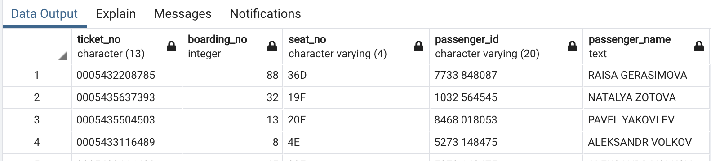

ANS : Select BO.ticket_no, BO.boarding_no, BO.seat_no,

T.passenger_id, T.passenger_name

From bookings.boarding_passes as BO

LEFT JOIN bookings.tickets as T

ON BO.ticket_no = T.ticket_no;

1. Which seat number is least allocated among all the seats?

Ans: Select seat_no, count(seat_no)

from bookings.boarding_passes

group by 1

order by 2 asc

limit 1;

1. In the database, identify the month-wise highest paying passenger name and passenger id

*Expected output*

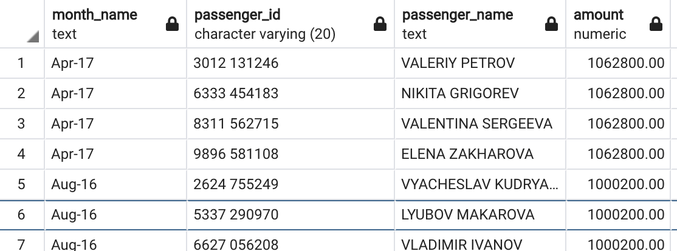

ANS : Select to_char(Bo.book_date, 'Mon-YY') month_name,

T.passenger_id, T.passenger_name, Bo.total_amount

from bookings.bookings as Bo

LEFT JOIN bookings.tickets as T

on Bo.book_ref = T.book_ref

GROUP BY 1, T.passenger_id, T.passenger_name,

Bo.total_amount

Order by 1 ASC, 4 DESC;

1. In the database, identify the month wise least paying passenger name and passenger id?

*Expected output*

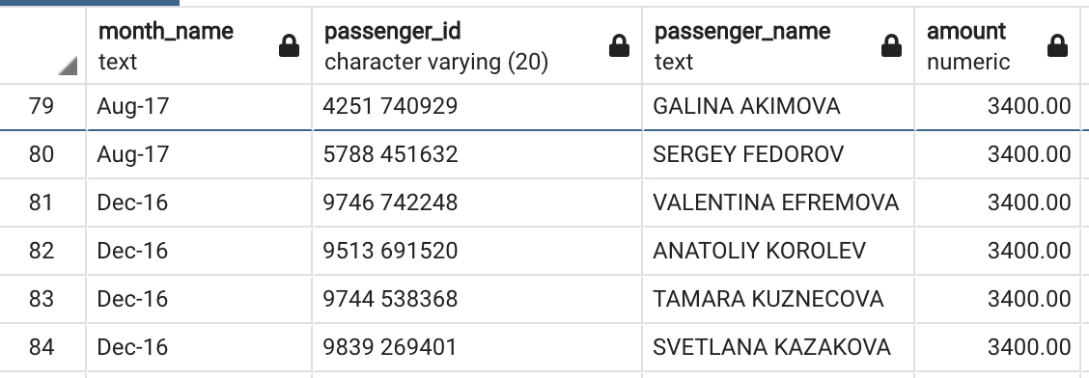

ANS: Select to_char(Bo.book_date, 'Mon-YY') month_name,

T.passenger_id, T.passenger_name, Bo.total_amount

from bookings.bookings as Bo

LEFT JOIN bookings.tickets as T

ON Bo.book_ref = T.book_ref

GROUP BY 1, T.passenger_id, T.passenger_name,

Bo.total_amount

Order by 1 ASC, 4 ASC;

1. Identify the travel details of nonstop journeys or return journeys (having more than 1 flight).

*Expected output*

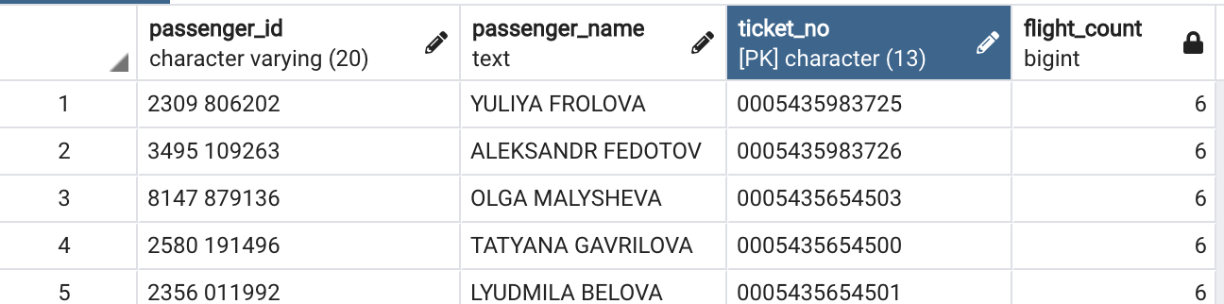

**ANS** : Select T.passenger_id, T.passenger_name, T.ticket_no, count(TF.flight_id) as

flight_count from bookings.tickets as T

INNER JOIN bookings.ticket_flights as TF

ON T.ticket_no = TF.ticket_no

GROUP BY T.passenger_id, T.passenger_name, T.ticket_no

Having count(TF.flight_id)>1

order by flight_count desc;

1. How many tickets are there without boarding passes?

**ANS:** Select count(t.ticket_no)

from bookings.tickets t

left join bookings.boarding_passes b on t.ticket_no = b.ticket_no

Group By boarding_no having boarding_no is null;

1. Identify details of the longest flight (using the flights table)?

Ans: Select distinct(flight_id),flight_no, aircraft_code,

Max(scheduled_arrival - scheduled_departure) as duration

from bookings.flights

Group by flight_id

Order by 4 DESC

LIMIT 1;

1. Categorize flights using following logic (using flights table) :
   1. Early morning flights: 2 AM to 6AM
   2. Morning flights: 6 AM to 11 AM
   3. Noon flights: 11 AM to 4 PM
   4. Evening flights: 4 PM to 7 PM
   5. Night flights: 7 PM to 11 PM
   6. Late Night flights: 11 PM to 2 AM

*Expected output*

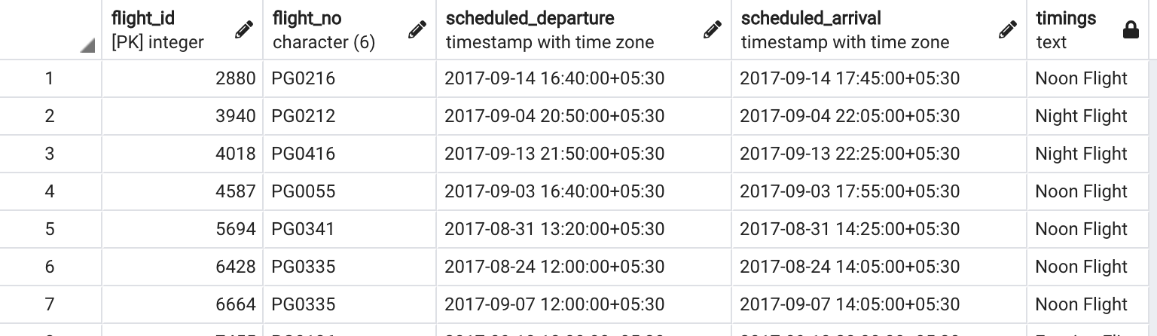

**Ans :** Select flight_id, flight_no, scheduled_departure, scheduled_arrival,

CASE when to_char(scheduled_departure, 'HH24:MI:SS') between '02:00:00' and '06:00:00'

then 'Early morning flights'

when to_char(scheduled_departure, 'HH24:MI:SS') between '06:00:00' and '11:00:00'

then 'Morning flights'

when to_char(scheduled_departure, 'HH24:MI:SS') between '11:00:00' and '16:00:00'

then 'Noon flights'

when to_char(scheduled_departure, 'HH24:MI:SS') between '16:00:00' and '19:00:00'

then 'Evening flights'

when to_char(scheduled_departure, 'HH24:MI:SS') between '19:00:00' and '23:00:00'

then 'Night flights'

when to_char(scheduled_departure, 'HH24:MI:SS') between '23:00:00' and '02:00:00'

then 'Late night flights'

END as timings

From bookings.flights;

10.Identify details of all the morning flights (morning means between 6AM to 11 AM, using flights table) ?

**ANS:** Select *, to_char(scheduled_departure, 'HH24:MI:SS') as timings

from bookings.flights

where to_char(scheduled_departure,'HH24:MI:SS')

between '06:00:00' and '11:00:00';

1. Identify the earliest morning flight available from every airport.

*Expected output*

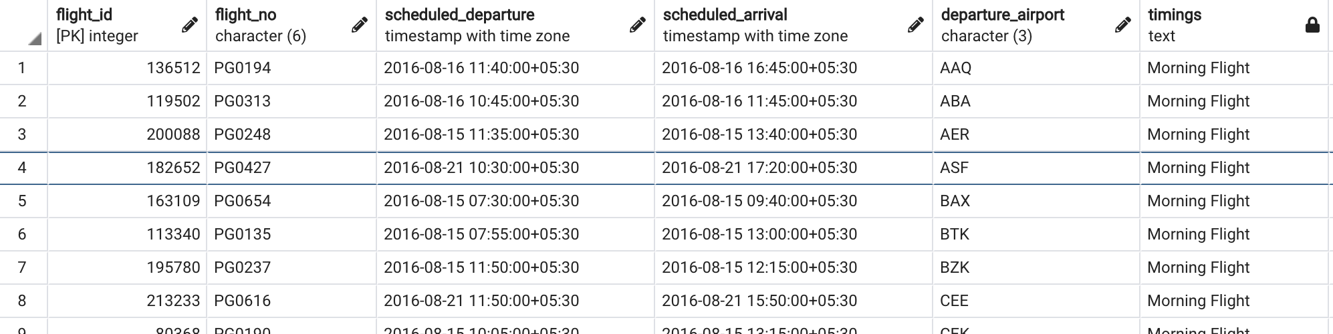

Ans Select flight_id, flight_no, scheduled_departure, scheduled_arrival, departure_airport,

to_char(scheduled_departure, 'HH24:MI:SS') as timings

from bookings.flights

where to_char(scheduled_departure,'HH24:MI:SS')

between '02:00:00' and '06:00:00'

group by flight_id

order by 2 ASC;